A
Practical activity Report submitted
for Engineering Design Project-II (UTA-024)
by
Group Number: 2
Class Batch: 2C23

Name of student | Roll number
Sandeep Yadav | 1024030312
Navjot Singh | 1024030313
Gagandeep Singh | 1024030314
Vikramaditya Singh | 1024030315
Shaina Gera | 1024030316

Submitted to
Vaibhav Bhardwaj



DEPARTMENT OF COMPUTER SCIENCE and ENGINEERING
THAPAR INSTITUTE OF ENGINEERING AND TECHNOLOGY,
(A DEEMED TO BE UNIVERSITY), PATIALA, PUNJAB
INDIA
Jan-June 2026
List of Experiments

Sr. No. | Experiment No. | Objective
1 | 1 | Introduction to Arduino Micro-Controller
2 | 2 | Write a program to blink a single LED using Arduino and breadboard
3 | 3 | Write a program in Arduino to blink multiple LEDs
4 | 4 | Write an Arduino program to design both forward and reverse pattern (1, 2, 3, 4, 5) sequence for different colour LEDs using following functions: delay(), for()
5 | 5 | Introduction to Serial Communications: Serial.begin(9600), Serial.print(), Serial.println(), Serial.read(), Serial.write(), Serial.available(), Serial.parseInt(), Serial.readString(), Serial.parseFloat().
6 | 6 | WAP for dimmer (Change in intensity of single and multiple LEDs) using Serial.read() and analogWrite()
7 | 7 | Introduction of NVIS Robocar specification
8 | 8 | Write a program to demonstrate control of DC Motor using forward, backward, left, right turn motion and clock-wise/anti clock-wise rotation
9 | 9 | Write a program to read values of IR Sensor using analog and digital read and convert buggy into normal line follower robocar
10 | 10 | To demonstrate the use of ultrasonic sensor by integrating line follower robocar with obstacle avoidance capability
11 | 11 | Write a program to read the pulse width of the gantry transmitter and trigger the stop buggy function by detecting individual gantry
13 | 12 | Bronze Challenge: Single buggy around track twice in clockwise direction, under full supervisory control. Buggy can detect an obstacle, Parks safely. Prints state of the track and buggy at each gantry stop

Experiment: 1
Objective: Introduction to Arduino Micro-Controller
Software Used: Tinkercad Simulator
Hardware Component Used:
Sr. No | Name of Components | Quantity
1. | Arduino Uno Micro-Controller | 1

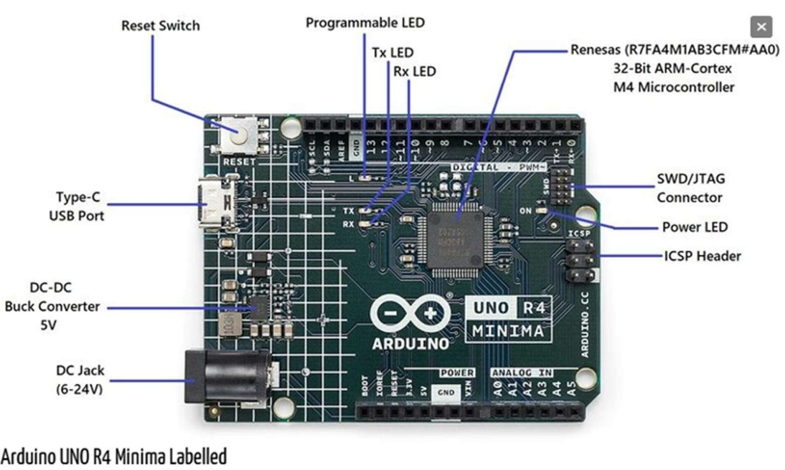
Figure 1.1: Arduino R4 Minima dev board
Theory:
- Arduino: The Arduino UNO R4 Minima, with the model number R7FA4M1AB3CFM#AA0, is a versatile development board packed with a multitude of features. It is the first UNO board featuring a 32-bit microcontroller from Renesas. It is faster, has more memory and has a number of built-in features such as a DAC, RTC and HID. The UNO R4 Minima is a 5 V only board. The UNO R4 Minima features a microcontroller based on the Renesas (Arm® Cortex®-M4) with an operating voltage of 5 V. It has 14 digital I/O, 6 analog inputs with up to 14-bit resolution, a clock speed of 48 MHz, and 32 kB SRAM, 256 kB flash memory & 8 kB of EEPROM. It features a DAC for audio projects, RTC for accurate time tracking and HID for emulating a keyboard/mouse. The barrel jack plug (VIN) supports voltages at up to 24V, making it compatible with common higher voltage adapters.
Here’s a comprehensive overview of its specifications:
- Microprocessor:
- Core: 48 MHz Arm® Cortex®-M4 microprocessor.
- Special Feature: Equipped with a floating-point unit (FPU) for enhanced computational capabilities.
- Power:
- Operating Voltage: 5 V.
- Input Voltage (VIN): Recommended range is 6-24 V.
- Power Source: Can be powered via a USB-C® at 5 V.
- Protection: Features Schottky diodes for overvoltage and reverse polarity protection.
- Connection: Barrel jack connected directly to the VIN pin.
- Memory:
  - Flash Memory: 256 kB.
  - SRAM: 32 kB.
  - Data Memory (EEPROM): 8 kB.
- Pins:
  - Digital Pins: 14x GPIO pins labeled D0-D13.
  - Analog Input Pins: 6x pins labeled A0-A5.
  - PWM Pins: 6x pins specifically D3, D5, D6, D9, D10, and D11.
- Peripherals:
  - Touch Sensing: Capacitive Touch Sensing Unit (CTSU)
  - USB Module: USB 2.0 Full-Speed Module (USBFS)
  - ADC: Up to 14-bit resolution (ADC Usage Guide)
  - DAC: Up to 12-bit resolution (DAC Usage Guide)
  - Additional Feature: Operational Amplifier (OPAMP)
- Communication protocols:
  - UART: Available on pins D0 and D1.
  - SPI: Accessible via pins D10-D13 and the ICSP header.
  - I2C: Available on pins A4, A5, SDA, and SCL.
  - CAN: Available on pins D4 and D5, but an external transceiver is required for operation.
- Special Features:
  - Real-time Clock (RTC): Ensures accurate timekeeping.
  - Memory Protection Unit (MPU): Provides enhanced security for memory sections.
  - Digital Analog Converter (DAC): Allows for precise analog operations.
With its robust set of features, the Arduino UNO R4 Minima is well-suited for a wide range of applications, from simple DIY projects to complex industrial applications.
Whether you’re a beginner or an experienced developer, this board offers the tools and flexibility needed to bring your ideas to life.

Discussion:
In this experiment, we get to know about basics of Arduino Uno Microcontroller and its various functions and components.

Signature of Faculty member

Experiment: 2
Objective: Write a program to blink a single LED using Arduino and breadboard.
Software Used: Tinkercad Simulator/Arduino IDE
Hardware Component Used:
Sr. No | Name of Components | Quantity
1. | Arduino Uno Board | 1
2. | Breadboard | 1
3. | Jumper Wires | 2
4. | LED | 1
5. | Resistor (220 Ω) | 1

Theory:
- Resistor: Resistors are used in virtually all electronic circuits and many electrical ones. Resistors, as their name indicates, resist the flow of electricity and this function is key to the operation of most circuits. The 220-ohm resistor is used to limit the current flowing through the LED to prevent it from burning out.
- LED: A light-emitting diode (LED) is a semiconductor light source that emits light when current flows through it. Electrons in the semiconductor recombine with electron holes, releasing energy in the form of photons (Energy packets). LEDs have polarity - the longer leg is the anode (positive) and the sho0rter leg is the cathode (negative).
- Arduino Uno Board: The Arduino Uno is an open-source microcontroller board based on the Microchip ATmega328P microcontroller and developed by Arduino.cc. It has 14 digital input/output pins, 6 analog inputs, and can be programmed using the Arduino IDE.

- Breadboard: A breadboard is used to place components (resistor, capacitor, LEDs etc.) that are wired together. It is used to make temporary circuits without soldering.

- Jumper Wires: A jumper wire is an electric wire that connects remote electric circuits used for printed circuit boards.

Code:
void setup()
{
pinMode(13, OUTPUT);
}
void loop()
{
digitalWrite(13, HIGH);
delay(1000);
digitalWrite(13, LOW);
delay(1000);
}

Results:
In this experiment, we successfully learned how to blink an LED using Arduino Uno. The LED turns ON for 1 second and OFF for 1 second repeatedly. This demonstrates the basic concept of digital output control using Arduino.
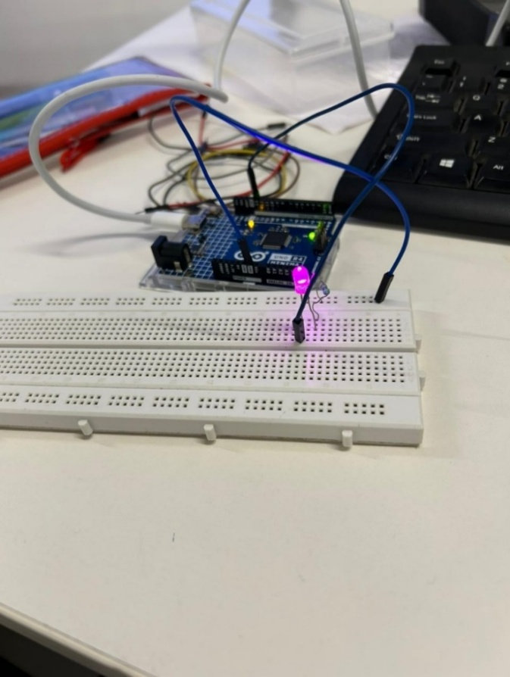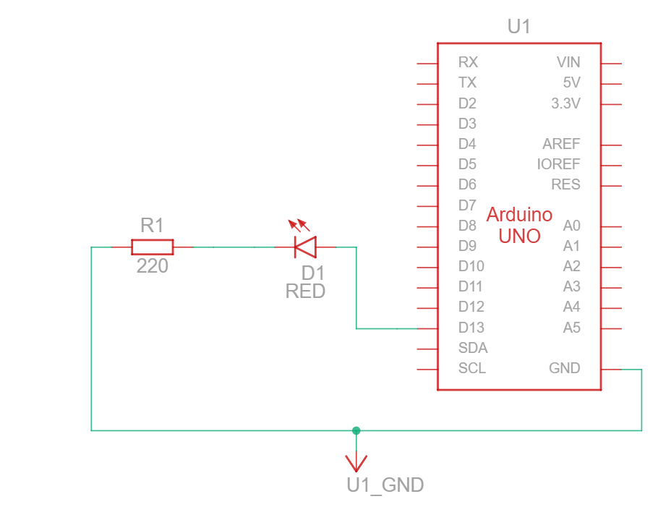
Figure 2.1: Breadboard connections Figure 2.2: Schematic Diagram

Signature of Faculty member

Experiment: 3
Objective: Write a program in Arduino to blink multiple LEDs.
Software Used: Tinkercad Simulator/Arduino IDE
Hardware Component Used:
Sr. No | Name of Components | Quantity
1. | Arduino Uno Board | 1
2. | Breadboard | 1
3. | Jumper Wires | As required
4. | LED (different colours) | 5
5. | Resistor (220 Ω) | 5

Theory:
Multiple LEDs can be controlled independently using different digital pins of Arduino. Each LED requires its own current-limiting resistor to prevent damage. By using arrays and loops in programming, we can efficiently control multiple LEDs with minimal code. This experiment demonstrates how to manage multiple outputs simultaneously and create various lighting patterns.

In this experiment, we use 5 LEDs connected to digital pins 8, 9, 10, 11, and 12 of the Arduino. Each LED can be controlled individually or in patterns using programming logic.

Connection Details:
- LED 1: Pin 8 → 220Ω Resistor → LED → GND
- LED 2: Pin 9 → 220Ω Resistor → LED → GND
- LED 3: Pin 10 → 220Ω Resistor → LED → GND
- LED 4: Pin 11 → 220Ω Resistor → LED → GND
- LED 5: Pin 12 → 220Ω Resistor → LED → GND

Code:
int ledPins[] = {8, 9, 10, 11, 12};
int numLeds = 5;
void setup()
{
for (int i = 0; i < numLeds; i++)
{
pinMode(ledPins[i], OUTPUT);
}
}
void loop()
{
// Turn all LEDs ON
for (int i = 0; i < numLeds; i++)
{
digitalWrite(ledPins[i], HIGH);
}
delay(1000);
// Turn all LEDs OFF
for (int i = 0; i < numLeds; i++)
{
digitalWrite(ledPins[i], LOW);
}
delay(1000);
}
Results:
In this experiment, we successfully controlled multiple LEDs using Arduino Uno. All five LEDs blink simultaneously - turning ON for 1 second and OFF for 1 second. This demonstrates the use of arrays and for loops to efficiently manage multiple digital outputs.

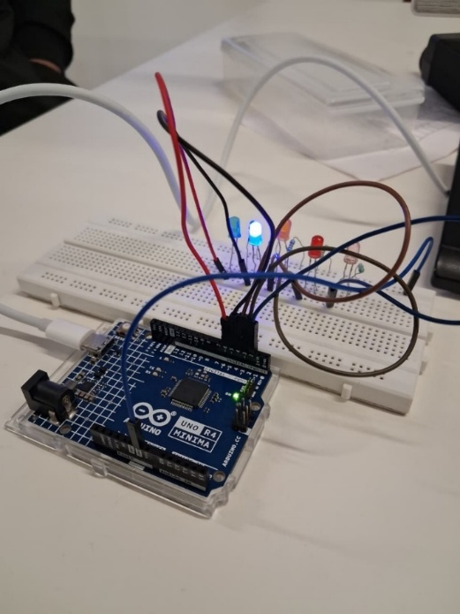
Figure 3.1: Breadboard Connections
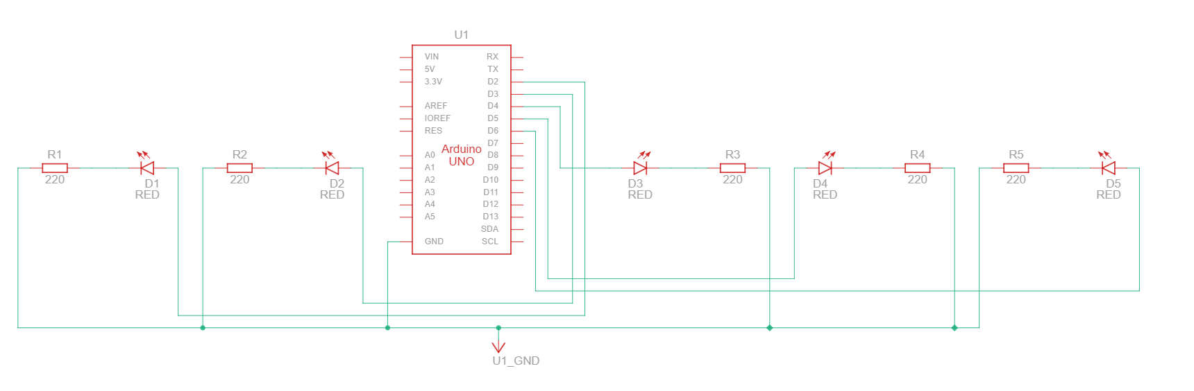
Figure 3.2: Schematic diagram

Signature of Faculty member

Experiment: 4
Objective: Write an Arduino program to design both forward and reverse pattern (1, 2, 3, 4, 5) sequence for different colour LEDs using following functions: delay(), for().
Software Used: Tinkercad Simulator/Arduino IDE
Hardware Component Used:
Sr. No | Name of Components | Quantity
1. | Arduino Uno Board | 1
2. | Breadboard | 1
3. | Jumper Wires | As required
4. | LED (different colours) | 5
5. | Resistor (220 Ω) | 5

Theory:
Sequential LED patterns are fundamental in understanding microcontroller programming and are widely used in decorative lighting, status indicators, and visual displays.
By using for loops, we can create both forward (1→2→3→4→5) and reverse (5→4→3→2→1) sequences efficiently.

The forward pattern lights up LEDs from the first to the last, while the reverse pattern does the opposite. This creates a "chasing" effect commonly seen in decorative lights. The delay() function controls the speed of the pattern by introducing a time gap between consecutive LED activations.

Connection Details:
- LED 1 (Red): Pin 8 → 220 Ω Resistor → LED → GND
- LED 2 (Yellow): Pin 9 → 220 Ω Resistor → LED → GND
- LED 3 (Green): Pin 10 → 220 Ω Resistor → LED → GND
- LED 4 (Blue): Pin 11 → 220 Ω Resistor → LED → GND
- LED 5 (White): Pin 12 → 220 Ω Resistor → LED → GND

Code:
int ledPins[] = {8, 9, 10, 11, 12};
int numLeds = 5;
int delayTime = 200;
void setup()
{
for (int i = 0; i < numLeds; i++)
{
pinMode(ledPins[i], OUTPUT);
}
}
void loop()
{
// Forward pattern: 1, 2, 3, 4, 5
for (int i = 0; i < numLeds; i++)
{
digitalWrite(ledPins[i], HIGH);
delay(delayTime);
digitalWrite(ledPins[i], LOW);
}
delay(500);
// Reverse pattern: 5, 4, 3, 2, 1
for (int i = numLeds - 1; i >= 0; i--)
{
digitalWrite(ledPins[i], HIGH);
delay(delayTime);
digitalWrite(ledPins[i], LOW);
}
delay(500);
}
Results:
In this experiment, we successfully created sequential LED patterns using for loops. The LEDs light up in forward sequence (1→2→3→4→5) followed by reverse sequence (5→4→3→2→1), creating a chasing light effect. This demonstrates the use of iterative loops and timing control in Arduino programming.
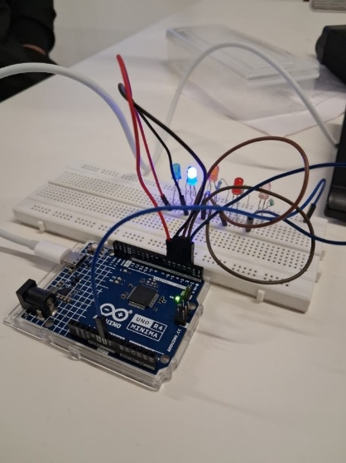
Figure 4.1: Breadboard Connections
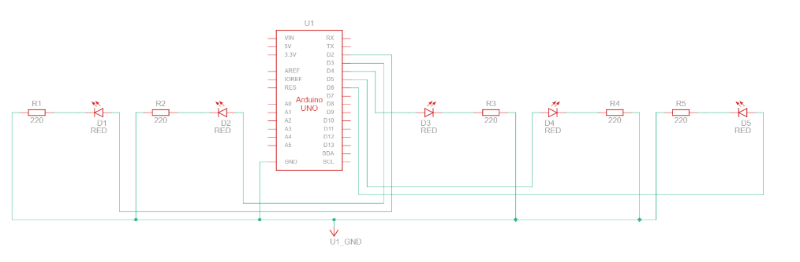
Figure 4.2: Schematic diagram

Signature of Faculty member

Experiment: 5
Objective: Introduction to Serial Communications: Serial.begin(9600), Serial.print(), Serial.println(), Serial.read(), Serial.write(), Serial.available(), Serial.parseInt(), Serial.readString(), Serial.parseFloat(). WAP for following pattern using for loop (as per requirement).

Software Used: Arduino IDE
Hardware Component Used:
Sr. No | Name of Components | Quantity
1. | Arduino Uno Board | 1
2. | USB Cable | 1

Theory:
Serial Communication is a method of sending data one bit at a time, sequentially over a communication channel. In Arduino, serial communication is used to communicate between the Arduino board and a computer or other devices.
Key Serial Functions:
- Serial.begin(9600): Initializes serial communication at 9600 baud rate (bits per second)
- Serial.print(): Prints data to serial port without adding a newline character
- Serial.println(): Prints data to serial port with a newline character at the end
- Serial.read(): Reads incoming serial data one byte at a time
- Serial.write(): Writes binary data to the serial port
- Serial.available(): Returns the number of bytes available to read from the serial buffer
- Serial.parseInt(): Reads incoming data and converts it to an integer value
- Serial.readString(): Reads characters from serial buffer into a string
- Serial.parseFloat(): Reads incoming data and converts it to a floating-point number
The Serial Monitor in Arduino IDE allows us to view the output sent from Arduino and also send data to the Arduino board for interactive communication.

Code:
void setup()
{
Serial.begin(9600);
String labels[] = {"Roll No. ", "Name: ", "Branch: "};
for (int i = 0; i < 3; i++)
{
// Print asterisks
for (int j = 0; j < 46; j++)
{
Serial.print("*");
}
Serial.println();
// Print label
Serial.print(labels[i]);
// Print underscores
for (int k = 0; k < 38; k++)
{
Serial.print("_");
}
Serial.println();
}
// Final line of asterisks
for (int j = 0; j < 46; j++)
{
Serial.print("*");
}
Serial.println();
}
void loop()
{
// Empty
}
Results:
In this experiment, we learned about serial communication functions in Arduino. We successfully created a formatted pattern using Serial.print() and Serial.println() functions with for loops. The pattern was displayed on the Serial Monitor, demonstrating effective data transmission from Arduino to computer.
Output (Serial Monitor):
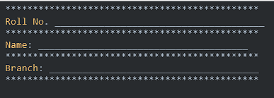

Signature of Faculty member

Experiment: 6
Objective: WAP for dimmer (Change in intensity of single and multiple LEDs) using Serial.read() and analogWrite().
Software Used: Arduino IDE
Hardware Component Used:
Sr. No | Name of Components | Quantity
1. | Arduino Uno Board | 1
2. | Breadboard | 1
3. | Jumper Wires | As required
4. | LED (different colours) | 5
5. | Resistor (220 Ω) | 5
6. | USB Cable | 1

Theory:
PWM (Pulse Width Modulation) is a technique used to control the brightness of LEDs by rapidly turning them ON and OFF. The Arduino Uno has 6 PWM pins (3, 5, 6, 9, 10, 11) marked with a "~" symbol. The analogWrite() function is used to output PWM signals with values ranging from 0 (always OFF) to 255 (always ON).

analogWrite(): This function writes an analog value (PWM wave) to a pin. The value can be from 0 to 255, where 0 means 0% duty cycle (LED OFF) and 255 means 100% duty cycle (LED at full brightness).

Serial.read(): Reads incoming serial data as bytes. This can be used to receive values from the Serial Monitor to control LED brightness dynamically.

In this experiment, we control the brightness of 5 LEDs based on different intensity ranges:
- LED 1: 1-50 (Dim)
- LED 2: 51-100 (Low-Medium)
- LED 3: 101-150 (Medium)
- LED 4: 151-200 (Medium-High)
- LED 5: 201-255 (Bright)

Code:
int ledPins[] = {3, 5, 6, 9, 10};
int brightness[] = {25, 75, 125, 175, 230};
void setup()
{
Serial.begin(9600);
for (int i = 0; i < 5; i++)
{
pinMode(ledPins[i], OUTPUT);
}
Serial.println("LED Dimmer Control");
Serial.println("LED 1: 1-50");
Serial.println("LED 2: 51-100");
Serial.println("LED 3: 101-150");
Serial.println("LED 4: 151-200");
Serial.println("LED 5: 201-255");
}
void loop()
{
// Display dimmer effect with predefined values
for (int i = 0; i < 5; i++)
{
analogWrite(ledPins[i], brightness[i]);
Serial.print("LED ");
Serial.print(i + 1);
Serial.print(" Brightness: ");
Serial.println(brightness[i]);
}
delay(2000);
// Turn all LEDs OFF
for (int i = 0; i < 5; i++)
{
analogWrite(ledPins[i], 0);
}
delay(1000);
}

Alternative Code (With Serial Input Control):
int ledPins[] = {3, 5, 6, 9, 10};
void setup()
{
Serial.begin(9600);
for (int i = 0; i < 5; i++)
{
pinMode(ledPins[i], OUTPUT);
}
Serial.println("Enter brightness value (0-255):");
}
void loop()
{
if (Serial.available() > 0)
{
int value = Serial.parseInt();
if (value >= 1 && value <= 50)
{
analogWrite(ledPins[0], value);
Serial.print("LED 1 set to: ");
Serial.println(value);
}
else if (value >= 51 && value <= 100)
{
analogWrite(ledPins[1], value);
Serial.print("LED 2 set to: ");
Serial.println(value);
}
else if (value >= 101 && value <= 150)
{
analogWrite(ledPins[2], value);
Serial.print("LED 3 set to: ");
Serial.println(value);
}
else if (value >= 151 && value <= 200)
{
analogWrite(ledPins[3], value);
Serial.print("LED 4 set to: ");
Serial.println(value);
}
else if (value >= 201 && value <= 255)
{
analogWrite(ledPins[4], value);
Serial.print("LED 5 set to: ");
Serial.println(value);
}
else
{
Serial.println("Invalid input. Enter value between 0-255.");
}
}
}

Results:
In this experiment, we successfully demonstrated LED dimming using PWM through the analogWrite() function. Five LEDs were controlled with different brightness levels based on specified ranges. We also implemented serial communication to dynamically control LED brightness from the Serial Monitor, showing the practical application of PWM in intensity control.
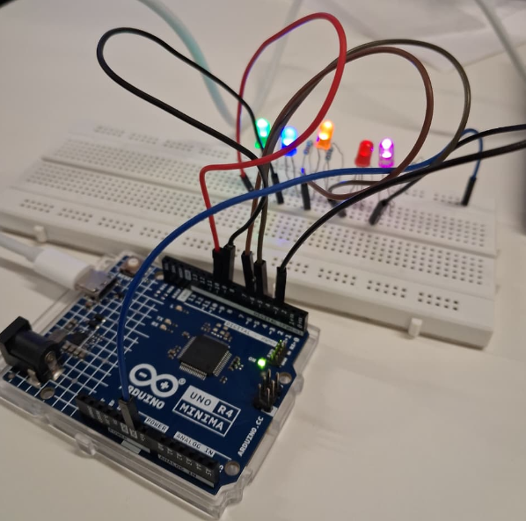
Figure 6.1: Breadboard Connections
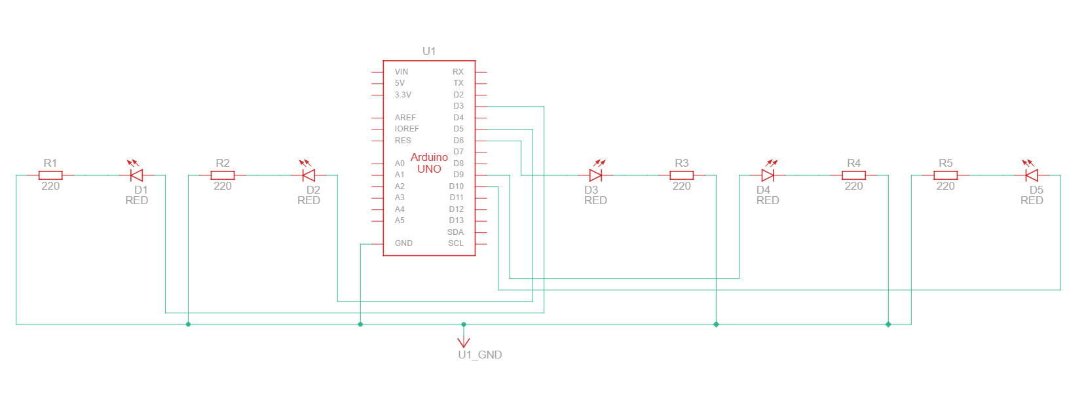
Figure 6.2: Schematic Diagram

Signature of Faculty member

Experiment: 7
Objective: Introduction of NVIS Robocar specification.
Software Used: Arduino IDE
Hardware Component Used:
Sr. No | Name of Components | Quantity
1. | NVIS 3302ARD RoboCar | 1
2. | USB Cable (Type B) | 1
3. | DC Adapter | 9V/700mA
4. | Rechargeable Battery | 8.4V/3000mAh

Theory:
NVIS 3302ARD RoboCar is an ATmega328P microcontroller-based robotic platform designed for learning robotics, sensor interfacing, and autonomous navigation. It is a ready-to-use assembled unit with various sensors and actuators integrated on a strong chassis.
Key Features:
- Processor:
  - Arduino-compatible ATmega328P microcontroller
  - 16 MHz crystal oscillator
  - FT232 PCB for USB programming
- Motor Control:
  - 2 metal geared 12V DC motors (150 rpm, 2 kg-cm torque)
  - L293D motor driver IC for bidirectional control
  - Supports forward, backward, left, right, and rotational movements
- Wireless Communication:
  - Onboard Zigbee 2.4 GHz module for remote control
  - Separate reset switch for Zigbee and controller
- Sensors:
  - Ultrasonic sensor for obstacle detection and distance measurement
  - Accelerometer (range: ±2g, ±4g, ±8g, ±16g)
  - Gyroscope (range: ±2g, ±4g, ±8g, ±16g)
  - 4 analog sensor inputs and 1 digital sensor input
- Expansion Capabilities:
  - 6 PWM connectors for servo motor interface
  - CBK male connectors for module interconnection
  - ISP programming connectors
  - 4 onboard SMD LEDs for digital output indication
- Power Supply:
  - Rechargeable Lithium battery: 8.4V/3000mAh
  - Onboard battery charger
  - DC charger supply: 9V/700mA
  - Separate regulated supply: +5V and +3.3V
- Physical Specifications:
  - Dimension: 190 × 190 × 80 mm (dual rim)
  - Weight: Approximately 1 kg
Applications:
- Line follower robot
- Obstacle avoidance robot
- Wireless controlled robot
- Sensor-based autonomous navigation
- Educational robotics projects

Programming: The NVIS 3302ARD is programmed using Arduino IDE through USB interface. It supports all standard Arduino libraries and can be programmed for various autonomous and remote-controlled operations.

Results:
In this experiment, we studied the specifications and capabilities of the NVIS 3302ARD RoboCar. We learned about its processor, motor control system, sensor interfaces, wireless communication module, and power management. This platform provides a comprehensive environment for developing intelligent robotic applications.
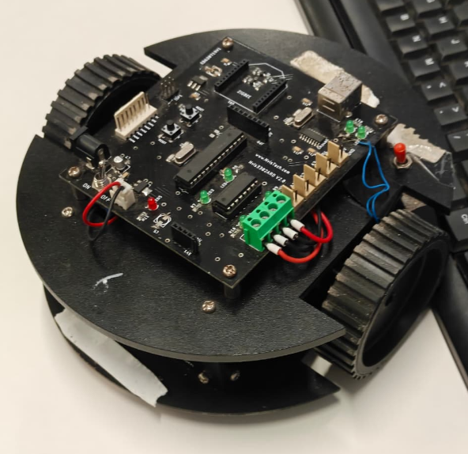
Figure 7.1: Picture of the NVIS Robocar

Signature of Faculty member

Experiment: 8
Objective: Introduction of NVIS Robocar specification.
Software Used: Arduino IDE
Hardware Component Used:
Sr. No | Name of Components | Quantity
1. | NVIS 3302ARD RoboCar | 1
2. | DC Motors | 2 (12V, 150rpm)
3. | L293D Motor Driver IC | 1
4. | USB Cable | 1

Theory:
DC Motor Control: DC motors convert electrical energy into mechanical rotation. In robotics, DC motors are used for locomotion. The NVIS RoboCar uses two DC motors - one for the left wheel and one for the right wheel. By controlling the direction and speed of these motors independently, we can achieve various movements.
L293D Motor Driver: The L293D is a dual H-bridge motor driver IC that allows bidirectional control of two DC motors. It can handle current up to 600mA per channel and operates at voltages from 4.5V to 36V.
Movement Control Logic:
- Forward: Both motors rotate in the forward direction
  - Left Motor: Forward, Right Motor: Forward
- Backward: Both motors rotate in the reverse direction
  - Left Motor: Backward, Right Motor: Backward
- Left Turn: Left motor stops/reverses while right motor moves forward
  - Left Motor: Stop/Backward, Right Motor: Forward
- Right Turn: Right motor stops/reverses while left motor moves forward
  - Left Motor: Forward, Right Motor: Stop/Backward
- Clockwise Rotation: Left motor forward, right motor backward
  - Left Motor: Forward, Right Motor: Backward
- Anti-Clockwise Rotation: Left motor backward, right motor forward
  - Left Motor: Backward, Right Motor: Forward

Pin Configuration (Typical):
- Motor 1 (Left): IN1, IN2 connected to digital pins
- Motor 2 (Right): IN3, IN4 connected to digital pins
- Enable pins: Connected to PWM pins for speed control

Code:
int b1 = 5;
int b2 = 6;
int a1 = 8;
int a2 = 7;
int delayTime = 1000;
void forward()
{
digitalWrite(a1, HIGH);
digitalWrite(b1, HIGH);
digitalWrite(a2, LOW);
digitalWrite(b2, LOW);
}
void backward()
{
digitalWrite(a1, LOW);
digitalWrite(b1, LOW);
digitalWrite(a2, HIGH);
digitalWrite(b2, HIGH);
}
void left()
{
digitalWrite(a1, LOW);
digitalWrite(b1, HIGH);
digitalWrite(a2, LOW);
digitalWrite(b2, LOW);
}
void right()
{
digitalWrite(a1, HIGH);
digitalWrite(b1, LOW);
digitalWrite(a2, LOW);
digitalWrite(b2, LOW);
}
void clockwise()
{
digitalWrite(a1, HIGH);
digitalWrite(b1, LOW);
digitalWrite(a2, LOW);
digitalWrite(b2, HIGH);
}
void anticlockwise()
{
digitalWrite(a1, LOW);
digitalWrite(b1, HIGH);
digitalWrite(a2, HIGH);
digitalWrite(b2, LOW);
}
void stopMotor()
{
digitalWrite(a1, LOW);
digitalWrite(b1, LOW);
digitalWrite(a2, LOW);
digitalWrite(b2, LOW);
}
void setup()
{
pinMode(a1, OUTPUT);
pinMode(b1, OUTPUT);
pinMode(a2, OUTPUT);
pinMode(b2, OUTPUT);
}
void loop()
{
forward();
delay(delayTime);
backward();
delay(delayTime);
left();
delay(delayTime);
right();
delay(delayTime);
clockwise();
delay(delayTime);
anticlockwise();
delay(delayTime);
stopMotor();
delay(delayTime);
}

Results:
In this experiment, we successfully demonstrated control of DC motors using the L293D motor driver IC. The RoboCar performed various movements including forward, backward, left turn, right turn, clockwise rotation, and anti-clockwise rotation. This experiment demonstrates the fundamental principles of differential drive robotics where independent control of two motors enables complex movements.

Signature of Faculty member

Experiment: 9
Objective: Write a program to read values of IR Sensor using analog and digital read and convert buggy into normal line follower robocar.
Software Used: Arduino IDE
Hardware Component Used:
Sr. No | Name of Components | Quantity
1. | NVIS 3302ARD RoboCar | 1
2. | IR Sensors | 2-5
3. | DC Motors (12V, 150 RPM) | 2
4. | L293D Motor Driver IC | 1
5. | USB Cable | 1
6. | Power Supply (8.4V Battery) | 1
7. | Black line track | 1

Theory:
IR (Infrared) Sensor: An IR sensor is an electronic device that emits and detects infrared radiation to sense characteristics of its surroundings. In line follower robots, IR sensors are used to detect the contrast between a black line and a white surface.
Working Principle: The IR sensor consists of an IR LED (transmitter) and a photodiode (receiver). The IR LED emits infrared light onto the surface. When infrared light falls on a white surface, it reflects back and is detected by the photodiode. When infrared light falls on a black surface, it is absorbed and very little light is reflected back. The photodiode resistance changes based on the amount of received infrared light.
IR Sensor Outputs:
Digital Output:
- Returns HIGH (1) when detecting white surface (line not detected)
- Returns LOW (0) when detecting black surface (line detected)
- Uses digitalRead() function
- Simple binary output, suitable for basic line following
Analog Output:
- Returns a value between 0-1023 based on reflected light intensity
- Higher values indicate more reflection (white surface)
- Lower values indicate less reflection (black surface)
- Uses analogRead() function
- Provides more detailed information about surface reflectivity
Line Follower Robot Logic: A line follower robot uses IR sensors to detect and follow a black line on a white surface. The basic algorithm involves positioning IR sensors on either side of the line and making decisions based on which sensor detects the black line.
Two Sensor Configuration:
- Left IR sensor and Right IR sensor positioned on either side of the line
- When both sensors detect white, move forward
- When left sensor detects black, turn left
- When right sensor detects black, turn right
- When both detect black, stop or move forward
Line Following Algorithm:
Left Sensor | Right Sensor | Action
WHITE | WHITE | Move Forward
BLACK | WHITE | Turn Left
WHITE | BLACK | Turn Right
BLACK | BLACK | Stop/Forward

Connection Details:
- IR Sensor 1 (Left): Digital Output → Arduino Pin 2, VCC → 5V, GND → GND
- IR Sensor 2 (Right): Digital Output → Arduino Pin 3, VCC → 5V, GND → GND
- Motor connections same as Experiment 8
Code:
// Motor Pin Definitions
#define LEFT_MOTOR_PIN1 5
#define LEFT_MOTOR_PIN2 6
#define RIGHT_MOTOR_PIN1 8
#define RIGHT_MOTOR_PIN2 7
// IR Sensor Pin Definitions
#define LEFT_IR_SENSOR A0
#define RIGHT_IR_SENSOR A1
void setup()
{
// Motor pins as OUTPUT
pinMode(LEFT_MOTOR_PIN1, OUTPUT);
pinMode(LEFT_MOTOR_PIN2, OUTPUT);
pinMode(RIGHT_MOTOR_PIN1, OUTPUT);
pinMode(RIGHT_MOTOR_PIN2, OUTPUT);
// IR sensor pins as INPUT
pinMode(LEFT_IR_SENSOR, INPUT);
pinMode(RIGHT_IR_SENSOR, INPUT);
Serial.begin(9600);
Serial.println("Line Follower Robot Initialized");
Serial.println("Place robot on track...");
delay(2000);
}
void loop()
{
// Read IR sensor values (0 = Black/Line, 1 = White/No Line)
int leftSensor = digitalRead(LEFT_IR_SENSOR);
int rightSensor = digitalRead(RIGHT_IR_SENSOR);
// Display sensor readings
Serial.print("Left: ");
Serial.print(leftSensor);
Serial.print(" | Right: ");
Serial.println(rightSensor);
// Line following logic
if (leftSensor == HIGH && rightSensor == HIGH)
{
Serial.println("Action: Moving Forward");
moveForward();
}
else if (leftSensor == LOW && rightSensor == HIGH)
{
Serial.println("Action: Turning Left");
turnLeft();
}
else if (leftSensor == HIGH && rightSensor == LOW)
{
Serial.println("Action: Turning Right");
turnRight();
}
else if (leftSensor == LOW && rightSensor == LOW)
{
Serial.println("Action: Both on Line - Moving Forward");
moveForward();
}
delay(50);
}
void moveForward()
{
digitalWrite(LEFT_MOTOR_PIN1, HIGH);
digitalWrite(LEFT_MOTOR_PIN2, LOW);
digitalWrite(RIGHT_MOTOR_PIN1, HIGH);
digitalWrite(RIGHT_MOTOR_PIN2, LOW);
}
void turnLeft()
{
digitalWrite(LEFT_MOTOR_PIN1, LOW);
digitalWrite(LEFT_MOTOR_PIN2, LOW);
digitalWrite(RIGHT_MOTOR_PIN1, HIGH);
digitalWrite(RIGHT_MOTOR_PIN2, LOW);
}
void turnRight()
{
digitalWrite(LEFT_MOTOR_PIN1, HIGH);
digitalWrite(LEFT_MOTOR_PIN2, LOW);
digitalWrite(RIGHT_MOTOR_PIN1, LOW);
digitalWrite(RIGHT_MOTOR_PIN2, LOW);
}
void stopMotors()
{
digitalWrite(LEFT_MOTOR_PIN1, LOW);
digitalWrite(LEFT_MOTOR_PIN2, LOW);
digitalWrite(RIGHT_MOTOR_PIN1, LOW);
digitalWrite(RIGHT_MOTOR_PIN2, LOW);
}

Calibration and Testing:
Sensor Calibration:
- Place sensors on white surface and note the analog reading
- Place sensors on black line and note the analog reading
- Set threshold as midpoint: threshold = (white value + black value) / 2
Track Preparation:
- Use black electrical tape (2-3 cm wide) on white surface
- Or use white surface with black marker line
- Ensure good contrast between line and background
Sensor Positioning:
- Mount sensors 2-5mm above the ground
- Keep sensors close to each other (1-2 cm apart)
- Ensure sensors are aligned perpendicular to the track
Observations:
- Digital read provides simple on/off detection, suitable for clear line contrast
- Analog read provides gradual values, better for detecting faded lines or gray surfaces
- Lower speeds provide better accuracy on sharp turns
- Optimal sensor height is 2-5mm for best detection
Troubleshooting:
- Robot not following line: Check sensor orientation and threshold value
- Robot oscillating: Reduce motor speed or adjust turning logic
- Robot losing line on curves: Add more sensors or reduce speed
- Inconsistent behavior: Calibrate sensors properly for ambient light
Results:
In this experiment, we successfully converted the NVIS RoboCar into a line follower robot using IR sensors. We learned to read sensor values using both digitalRead() and analogRead() functions. The robot successfully detected and followed a black line on a white surface using the differential drive mechanism. We implemented line following algorithms demonstrating how sensor feedback controls motor movements for autonomous navigation.

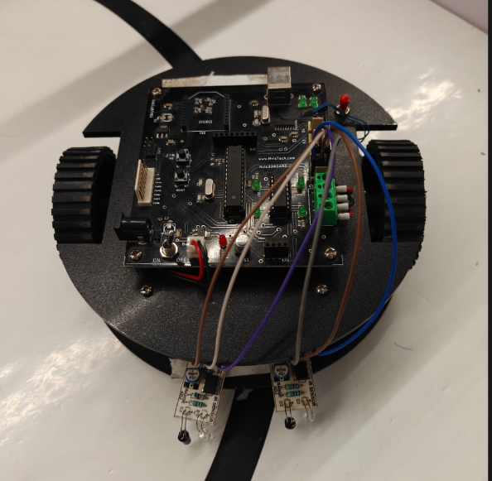
Figure 9.1: Robocar with IR sensors installed

Signature of Faculty member

Experiment: 10
Objective: To demonstrate the use of ultrasonic sensor by integrating line follower robocar with obstacle avoidance capability.
Software Used: Arduino IDE
Hardware Component Used:
Sr. No | Name of Components | Quantity
1. | NVIS 3302ARD RoboCar | 1
2. | Ultrasonic Sensor (HC-SR04) | 1
3. | IR Sensors | 2-3
4. | DC Motors (12V, 150 RPM) | 2
5. | L293D Motor Driver IC | 1
6. | USB Cable | 1
7. | Power Supply (8.4V Battery) | 1
8. | Jumper Wires | As required

Theory:
Ultrasonic Sensor (HC-SR04): An ultrasonic sensor is a device that uses ultrasonic sound waves to measure distance to an object. The HC-SR04 ultrasonic sensor is commonly used in robotics for obstacle detection and distance measurement.
Working Principle: The sensor has a transmitter (TRIG pin) and receiver (ECHO pin). A trigger pulse is sent to the TRIG pin (10μs HIGH pulse). The transmitter emits 8 ultrasonic sound pulses at 40kHz. These sound waves travel through the air. When waves hit an obstacle, they reflect back. The receiver detects the reflected waves. The ECHO pin outputs a pulse whose width is proportional to the distance.
Distance Calculation:
Distance = (Time × Speed of Sound) / 2
Distance (cm) = (Duration in microseconds × 0.034) / 2
Distance (cm) = Duration / 58
The division by 2 is because the sound travels to the object and back.
HC-SR04 Specifications:
- Operating Voltage: 5V DC
- Operating Current: 15mA
- Frequency: 40kHz
- Range: 2cm to 400cm
- Measuring Angle: 15 degrees
- Trigger Input: 10μs TTL pulse
- Echo Output: TTL pulse proportional to distance
Pin Configuration:
- VCC: +5V power supply
- TRIG: Trigger input pin
- ECHO: Echo output pin
- GND: Ground
Obstacle Avoidance Logic:
The robot combines line following with obstacle avoidance:
- Normal Operation: Follow the black line using IR sensors
- Obstacle Detection: Continuously monitor distance using ultrasonic sensor
- Obstacle Threshold: If distance < threshold (e.g., 20cm), obstacle detected
- Avoidance Action:
  - Stop the robot
  - Turn left or right to avoid obstacle
  - Resume line following after clearance
Integrated Algorithm:
- Read ultrasonic sensor distance
- If distance < obstacle threshold, then perform obstacle avoidance
- Else follow line using IR sensors
- Repeat
Connection Details:
- Ultrasonic Sensor: TRIG → Pin 11, ECHO → Pin 12, VCC → 5V, GND → GND
- IR Sensors: Same as Experiment 9
- Motors: Same as Experiment 8
Code:
// Motor Pin Definitions
#define LEFT_MOTOR_PIN1 4
#define LEFT_MOTOR_PIN2 5
#define RIGHT_MOTOR_PIN1 6
#define RIGHT_MOTOR_PIN2 7
#define LEFT_MOTOR_ENABLE 9
#define RIGHT_MOTOR_ENABLE 10
// IR Sensor Pin Definitions
#define LEFT_IR_SENSOR 2
#define RIGHT_IR_SENSOR 3
// Ultrasonic Sensor Pin Definitions
#define TRIG_PIN 11
#define ECHO_PIN 12
// Constants
int motorSpeed = 180;
int obstacleThreshold = 20;
void setup()
{
// Motor pins
pinMode(LEFT_MOTOR_PIN1, OUTPUT);
pinMode(LEFT_MOTOR_PIN2, OUTPUT);
pinMode(RIGHT_MOTOR_PIN1, OUTPUT);
pinMode(RIGHT_MOTOR_PIN2, OUTPUT);
pinMode(LEFT_MOTOR_ENABLE, OUTPUT);
pinMode(RIGHT_MOTOR_ENABLE, OUTPUT);
// IR sensors
pinMode(LEFT_IR_SENSOR, INPUT);
pinMode(RIGHT_IR_SENSOR, INPUT);
// Ultrasonic
pinMode(TRIG_PIN, OUTPUT);
pinMode(ECHO_PIN, INPUT);
// Speed control
analogWrite(LEFT_MOTOR_ENABLE, motorSpeed);
analogWrite(RIGHT_MOTOR_ENABLE, motorSpeed);
Serial.begin(9600);
Serial.println("Line Follower with Obstacle Avoidance Initialized");
delay(2000);
}
void loop()
{
long distance = getDistance();
Serial.print("Distance: ");
Serial.print(distance);
Serial.println(" cm");
if (distance > 0 && distance < obstacleThreshold)
{
Serial.println("OBSTACLE DETECTED");
handleObstacle();
}
else
{
followLine();
}
delay(50);
}
long getDistance()
{
digitalWrite(TRIG_PIN, LOW);
delayMicroseconds(2);
digitalWrite(TRIG_PIN, HIGH);
delayMicroseconds(10);
digitalWrite(TRIG_PIN, LOW);
long duration = pulseIn(ECHO_PIN, HIGH, 30000);
long distance = duration / 58;
return distance;
}
void followLine()
{
int leftSensor = digitalRead(LEFT_IR_SENSOR);
int rightSensor = digitalRead(RIGHT_IR_SENSOR);
Serial.print("IR - Left: ");
Serial.print(leftSensor);
Serial.print(" Right: ");
Serial.println(rightSensor);
if (leftSensor == HIGH && rightSensor == HIGH)
{
moveForward();
}
else if (leftSensor == LOW && rightSensor == HIGH)
{
turnLeft();
}
else if (leftSensor == HIGH && rightSensor == LOW)
{
turnRight();
}
else
{
moveForward();
}
}
void handleObstacle()
{
stopMotors();
delay(500);
moveBackward();
delay(800);
rotateRight();
delay(600);
moveForward();
delay(1000);
rotateLeft();
delay(600);
}
// Motor Functions
void moveForward()
{
digitalWrite(LEFT_MOTOR_PIN1, HIGH);
digitalWrite(LEFT_MOTOR_PIN2, LOW);
digitalWrite(RIGHT_MOTOR_PIN1, HIGH);
digitalWrite(RIGHT_MOTOR_PIN2, LOW);
}
void moveBackward()
{
digitalWrite(LEFT_MOTOR_PIN1, LOW);
digitalWrite(LEFT_MOTOR_PIN2, HIGH);
digitalWrite(RIGHT_MOTOR_PIN1, LOW);
digitalWrite(RIGHT_MOTOR_PIN2, HIGH);
}
void turnLeft()
{
digitalWrite(LEFT_MOTOR_PIN1, LOW);
digitalWrite(LEFT_MOTOR_PIN2, LOW);
digitalWrite(RIGHT_MOTOR_PIN1, HIGH);
digitalWrite(RIGHT_MOTOR_PIN2, LOW);
}
void turnRight()
{
digitalWrite(LEFT_MOTOR_PIN1, HIGH);
digitalWrite(LEFT_MOTOR_PIN2, LOW);
digitalWrite(RIGHT_MOTOR_PIN1, LOW);
digitalWrite(RIGHT_MOTOR_PIN2, LOW);
}
void rotateLeft()
{
digitalWrite(LEFT_MOTOR_PIN1, LOW);
digitalWrite(LEFT_MOTOR_PIN2, HIGH);
digitalWrite(RIGHT_MOTOR_PIN1, HIGH);
digitalWrite(RIGHT_MOTOR_PIN2, LOW);
}
void rotateRight()
{
digitalWrite(LEFT_MOTOR_PIN1, HIGH);
digitalWrite(LEFT_MOTOR_PIN2, LOW);
digitalWrite(RIGHT_MOTOR_PIN1, LOW);
digitalWrite(RIGHT_MOTOR_PIN2, HIGH);
}
void stopMotors()
{
digitalWrite(LEFT_MOTOR_PIN1, LOW);
digitalWrite(LEFT_MOTOR_PIN2, LOW);
digitalWrite(RIGHT_MOTOR_PIN1, LOW);
digitalWrite(RIGHT_MOTOR_PIN2, LOW);
}
Testing Procedure:
Ultrasonic Sensor Testing:
- Upload a simple distance measurement code
- Place objects at known distances (10cm, 20cm, 30cm)
- Verify sensor readings are accurate
Integration Testing:
- Place robot on line follower track
- Place obstacles at various points on the track
- Observe robot behavior when approaching obstacles
Calibration:
- Adjust obstacle threshold based on robot speed and braking distance
- Fine-tune avoidance maneuver timings
- Test on different track configurations
Observations:
- Higher speeds require greater detection distance
- HC-SR04 has 15 degree sensing angle, position carefully
- Ultrasonic works best with hard, flat surfaces
- Adding more IR sensors improves line tracking during avoidance
Advantages of Integrated System:
- Autonomous navigation on predefined path
- Safe operation with obstacle detection
- Reduced collision risk
- Applicable in warehouse automation, delivery robots
Limitations:
- Ultrasonic may not detect small or soft objects
- Sound-absorbing materials can reduce detection range
- Requires careful tuning of avoidance maneuvers
Troubleshooting:
- No distance reading: Check TRIG and ECHO connections, verify 5V power
- Erratic readings: Ensure sensor is stable, avoid electrical noise sources
- Robot losing line after avoidance: Improve avoidance algorithm, add more IR sensors
- Collision despite detection: Reduce speed or increase obstacle threshold distance
Results:
In this experiment, we successfully integrated an ultrasonic sensor with a line follower robot to create an intelligent obstacle-avoiding robocar. The robot demonstrated the ability to follow a black line using IR sensors, continuously monitor for obstacles using ultrasonic sensor, stop and avoid obstacles when detected within threshold distance, and resume line following after successful obstacle avoidance. We learned how to measure distance using ultrasonic sensors through time-of-flight calculations, integrated multiple sensor inputs (IR and ultrasonic) into a single control algorithm, and implemented adaptive behavior based on sensor feedback. This experiment demonstrates a practical application of sensor fusion in autonomous robotics.
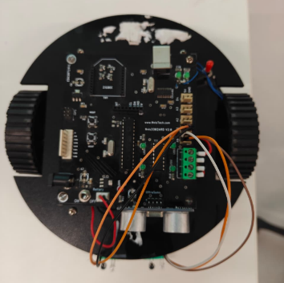
Figure 10.1: Robocar with IR sensors and ultrasonic sensor installed

Signature of Faculty member

Experiment: 11
Objective: Write a program to read the pulse width of the gantry transmitter and trigger the stop buggy function by detecting individual gantry.
Software Used: Arduino IDE
Hardware Component Used:
Sr. No | Name of Components | Quantity
1. | NVIS 3302ARD RoboCar | 1
2. | IR Sensors | 2
3. | Gantry Transmitter | 3
4. | DC Motors (12V, 150 RPM) | 2
5. | L293D Motor Driver IC | 1
6. | IR Receiver Module | 1
7. | Ultrasonic Sensor (HC-SR04) | 1
8. | XBee Module | 1
9. | USB Cable | 1
10. | Power Supply (8.4V Battery) | 1
11. | Jumper Wires | As required

Theory:
Gantry System: A gantry is a structure that spans over a track or pathway. In robotics, a gantry transmitter system is used to create checkpoints or waypoints along a track. The gantry transmitter emits infrared signals with specific pulse widths that can be detected by an IR receiver on the robot. Each gantry can transmit a unique pulse width, allowing the robot to identify different gantry positions.
Pulse Width: Pulse width refers to the duration for which a signal remains in the HIGH state. Different gantries transmit pulses of different widths (measured in microseconds), creating unique identifiers for each checkpoint.
Working Principle: The IR receiver on the robot continuously monitors for incoming infrared signals. When the robot passes under a gantry, the IR receiver detects the transmitted signal and measures its pulse width using the pulseIn() function. Based on the measured pulse width, the robot can identify which gantry it has encountered and perform specific actions such as stopping and logging the checkpoint.
pulseIn() Function: The pulseIn() function reads a pulse (either HIGH or LOW) on a pin. It returns the length of the pulse in microseconds.
Syntax: pulseIn(pin, value, timeout)
- pin: The pin on which to read the pulse
- value: Type of pulse to read (HIGH or LOW)
- timeout: Maximum time to wait for pulse in microseconds
XBee Communication: XBee modules provide wireless communication between the robot and a control station. The robot waits for a start command ('x') from the XBee coordinator before beginning operation. This allows remote control and monitoring of the robot.
NewPing Library: The NewPing library simplifies ultrasonic sensor interfacing. The ping_cm() function directly returns distance in centimeters, making obstacle detection more efficient.
Gantry Detection Logic:
- Robot waits for start command from XBee module
- Once started, robot follows the line using IR sensors
- IR receiver continuously monitors for gantry signals
- When pulse is detected, measure pulse width using pulseIn()
- Compare pulse width with predefined ranges to identify gantry
- Stop buggy and log gantry detection
- Prevent multiple detections using prevGantry variable
- Resume line following after delay
- Continuously check for obstacles using ultrasonic sensor
Pulse Width Ranges:
Gantry ID | Pulse Width Range (μs) | Action
Gantry 1 | 500-1500 | Stop and log Gantry 1
Gantry 2 | 1500-2500 | Stop and log Gantry 2
Gantry 3 | 2500-3500 | Stop and log Gantry 3

Connection Details:
- Right Motor: Pin 5 (+ve), Pin 6 (-ve)
- Left Motor: Pin 7 (+ve), Pin 8 (-ve)
- Left IR Sensor: A0
- Right IR Sensor: A1
- Gantry Receiver: A2
- Ultrasonic Sensor: TRIG → Pin 13, ECHO → Pin 12
- XBee Module: TX → RX, RX → TX (Serial communication)

Code:
#include <NewPing.h>
bool start = false;
const int trigPin = 13;
const int echoPin = 12;
const int maxDistance = 20;
NewPing sonar(trigPin, echoPin, maxDistance);
long duration;
int distanceCm;
int prevGantry = 0;
void setup()
{
pinMode(5, OUTPUT); // Right Tyre +ve
pinMode(6, OUTPUT); // Right Tyre -ve
pinMode(7, OUTPUT); // Left Tyre +ve
pinMode(8, OUTPUT); // Left Tyre -ve
pinMode(A0, INPUT); // Left IR
pinMode(A1, INPUT); // Right IR
pinMode(A2, INPUT); // Receiver Ckt
pinMode(trigPin, OUTPUT);
pinMode(echoPin, INPUT);
Serial.begin(9600);
}
// Movement Functions
void Forward()
{
digitalWrite(5, HIGH);
digitalWrite(6, LOW);
digitalWrite(7, HIGH);
digitalWrite(8, LOW);
}
void Backward()
{
digitalWrite(5, LOW);
digitalWrite(6, HIGH);
digitalWrite(7, LOW);
digitalWrite(8, HIGH);
}
void Left()
{
digitalWrite(5, HIGH);
digitalWrite(6, LOW);
digitalWrite(7, LOW);
digitalWrite(8, LOW);
}
void Right()
{
digitalWrite(5, LOW);
digitalWrite(6, LOW);
digitalWrite(7, HIGH);
digitalWrite(8, LOW);
}
void Anti()
{
digitalWrite(5, HIGH);
digitalWrite(6, LOW);
digitalWrite(7, LOW);
digitalWrite(8, HIGH);
}
void Clock()
{
digitalWrite(5, LOW);
digitalWrite(6, HIGH);
digitalWrite(7, HIGH);
digitalWrite(8, LOW);
}
void Stop()
{
digitalWrite(5, LOW);
digitalWrite(6, LOW);
digitalWrite(7, LOW);
digitalWrite(8, LOW);
}
void loop()
{
if (Serial.available())
{
char a = Serial.read();
if (a == 'x')
{
start = true;
}
}
if (start)
{
int d0 = digitalRead(A0); // Left IR
int d1 = digitalRead(A1); // Right IR
int g = pulseIn(A2, HIGH, 5000); // Gantry pulse
// Gantry detection logic (FIXED: was assignment "=" instead of comparison "==")
if (g > 500 && g <= 1500 && prevGantry != 1)
{
Serial.println("gantry 1");
Stop();
delay(1000);
prevGantry = 1;
}
else if (g > 1500 && g <= 2500 && prevGantry != 2)
{
Serial.println("gantry 2");
Stop();
delay(1000);
prevGantry = 2;
}
else if (g > 2500 && g <= 3500 && prevGantry != 3)
{
Serial.println("gantry 3");
Stop();
delay(1000);
prevGantry = 3;
}
// Line following
if (d0 == 0 && d1 == 0)
{
Forward();
}
else if (d0 == 0)
{
Left();
}
else if (d1 == 0)
{
Right();
}
else
{
Forward();
}
// Obstacle detection
distanceCm = sonar.ping_cm();
if (distanceCm > 0 && distanceCm < 15)
{
Stop();
delay(500);
}
}
}

Observations:
- The start flag ensures robot only operates after receiving XBee command
- prevGantry variable prevents repeated detection of same gantry
- pulseIn() timeout of 5000 microseconds prevents blocking
- NewPing library simplifies distance measurement
- Obstacle detection runs continuously regardless of start flag
- IR sensor value 0 indicates black line detection (inverted logic)
Applications:
- Checkpoint systems in automated guided vehicles (AGV)
- Lap counting in racing robots
- Waypoint navigation in autonomous systems
- Position tracking in warehouse automation
- Remote controlled industrial robots
Advantages:
- Wireless start control using XBee
- Non-contact gantry detection system
- Integrated obstacle avoidance
- Prevention of multiple detections using prevGantry
- Simple and efficient code structure
- Real-time position logging via serial communication
Limitations:
- Requires line of sight between gantry transmitter and receiver
- Pulse width ranges must be non-overlapping
- Limited to 3 gantries in current implementation
- XBee communication range limitations
- Ultrasonic sensor may not detect small objects
Troubleshooting:
- Robot not starting: Check XBee connection, send 'x' character
- No pulse detected: Verify gantry transmitter, check A2 connection
- Wrong gantry identified: Recalibrate pulse width ranges
- Multiple detections: prevGantry logic should prevent this, check for sensor noise
- Line following issues: Verify IR sensor connections and ground detection
- Obstacle not detected: Check ultrasonic sensor connections and NewPing library installation
Results:
In this experiment, we successfully implemented a comprehensive gantry detection system with wireless control and obstacle avoidance. The robot demonstrated the ability to wait for wireless start command via XBee module, follow a line using IR sensors, detect and identify three different gantries based on pulse width measurement, stop at each gantry and log detection via serial communication, prevent multiple detections of the same gantry using prevGantry variable, and detect obstacles using ultrasonic sensor with NewPing library. We learned how to integrate multiple systems (line following, gantry detection, obstacle avoidance, wireless communication) into a single autonomous robot, implement state management using boolean flags, and use the pulseIn() function with timeout for reliable pulse width measurement. This experiment demonstrates a complete autonomous navigation system suitable for industrial and competition robotics applications.
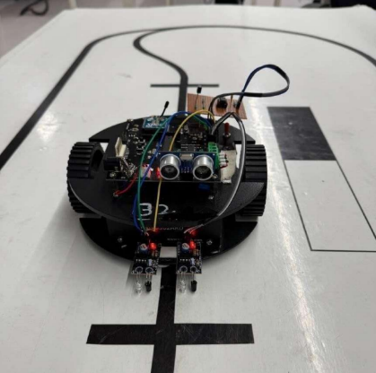
Figure 11.1: Robocar with Sensors attached

Signature of Faculty member

Experiment: 12
Objective: Bronze Challenge: Single buggy around track twice in clockwise direction, under full supervisory control. Buggy can detect an obstacle, Parks safely. Prints state of the track and buggy at each gantry stop.
Software Used: Arduino IDE
Hardware Component Used:
Sr. No | Name of Components | Quantity
1. | NVIS 3302ARD RoboCar | 1
2. | IR Sensors | 2
3. | Gantry Transmitters | 3
4. | Ultrasonic Sensor (HC-SR04) | 1
5. | IR Receiver Module | 1
6. | XBee Module | 1
7. | DC Motors (12V, 150 RPM) | 2
8. | L293D Motor Driver IC | 1
9. | USB Cable | 1
10. | Power Supply (8.4V Battery) | 1
11. | Black line track | 1

Theory:
Bronze Challenge Requirements:
The Bronze Challenge is a comprehensive robotics task that integrates multiple functionalities:
- Line following capability using IR sensors
- Wireless supervisory control using XBee communication
- Gantry detection and logging at checkpoints
- Obstacle detection and avoidance using ultrasonic sensor
- Autonomous parking at designated location
- State reporting at each gantry
System Components:
XBee Communication: The system uses wireless XBee modules for supervisory control. The buggy waits for a start command ('x') from the coordinator before beginning operation. This ensures controlled and safe testing.
Line Following: Two IR sensors detect the black line on a white surface. The sensors return 0 for black and 1 for white surfaces, enabling the buggy to follow the track.
Gantry Detection: IR receiver monitors for pulse signals from overhead gantries. Each gantry transmits a unique pulse width, allowing identification and position tracking.
Obstacle Detection: Ultrasonic sensor continuously monitors the path ahead. If an obstacle is detected within 15 cm, the buggy stops immediately for safety.
Parking Logic: The system uses a Black-Black detection counter to identify parking zones. When both IR sensors detect black simultaneously for a sufficient duration, it indicates a parking line or junction. The counter increments through different stages to navigate into the parking area.
Parking Sequence:
Counter | Detection | Action | Description
0 | Black-Black | Forward 25ms | Cross parking line
1 | Black-Black | Left 20ms | Align for turn
2 | Black-Black | Forward 13ms | Exit current path
3 | Black-Black | Left 150ms | Turn into parking
4 | Black-Black | Forward 10ms | Final positioning
5+ | Black-Black | Stop | Parked successfully

Time Duration Logic:
The system uses time intervals to prevent false detections. The currentTime - prevTime comparison ensures that Black-Black detections are spaced appropriately, avoiding rapid counter increments from a single parking line.
Gantry Pulse Width Ranges:
Gantry ID | Pulse Width Range (μs) | Action
Gantry 1 | 500-999 | Stop and log "gantry 111"
Gantry 2 | 1000-1999 | Stop and log "gantry 222"
Gantry 3 | 2000-2999 | Stop and log "gantry 333"
Connection Details:
- Right Motor: Pin 5 (+ve), Pin 6 (-ve)
- Left Motor: Pin 7 (+ve), Pin 8 (-ve)
- Left IR Sensor: A0
- Right IR Sensor: A1
- Gantry Receiver: A2
- Ultrasonic Sensor: TRIG → Pin 13, ECHO → Pin 12
- XBee Module: TX → RX, RX → TX (Serial communication at 9600 baud)
Code:
#include <NewPing.h>
bool start = false;
const int trigPin = 13;
const int echoPin = 12;
const int maxDistance = 20;
NewPing sonar(trigPin, echoPin, maxDistance);
int distanceCm;
int counter = 0;
int prevGantry = 0;
unsigned long prevTime = 0;
unsigned long currentTime;
// ---------------- SETUP ----------------
void setup()
{
pinMode(5, OUTPUT); // Right +
pinMode(6, OUTPUT); // Right -
pinMode(7, OUTPUT); // Left +
pinMode(8, OUTPUT); // Left -
pinMode(A0, INPUT); // Left IR
pinMode(A1, INPUT); // Right IR
pinMode(A2, INPUT); // Receiver
pinMode(trigPin, OUTPUT);
pinMode(echoPin, INPUT);
Serial.begin(9600);
}
// ---------------- MOTOR FUNCTIONS ----------------
void Forward()
{
digitalWrite(5, HIGH);
digitalWrite(6, LOW);
digitalWrite(7, HIGH);
digitalWrite(8, LOW);
}
void Backward()
{
digitalWrite(5, LOW);
digitalWrite(6, HIGH);
digitalWrite(7, LOW);
digitalWrite(8, HIGH);
}
void Left()
{
digitalWrite(5, HIGH);
digitalWrite(6, LOW);
digitalWrite(7, LOW);
digitalWrite(8, LOW);
}
void Right()
{
digitalWrite(5, LOW);
digitalWrite(6, LOW);
digitalWrite(7, HIGH);
digitalWrite(8, LOW);
}
void Stop()
{
digitalWrite(5, LOW);
digitalWrite(6, LOW);
digitalWrite(7, LOW);
digitalWrite(8, LOW);
}
// ---------------- LOOP ----------------
void loop()
{
// Start trigger from Zigbee
if (Serial.available())
{
char a = Serial.read();
if (a == 'x')
{
start = true;
}
}
if (start)
{
int d0 = digitalRead(A0);
int d1 = digitalRead(A1);
int g = pulseIn(A2, HIGH, 5000);
// -------- GANTRY FIX (was broken before) --------
if (g >= 500 && g < 1000 && prevGantry != 1)
{
Serial.println("gantry 1");
Stop();
delay(1000);
prevGantry = 1;
}
else if (g >= 1000 && g < 2000 && prevGantry != 2)
{
Serial.println("gantry 2");
Stop();
delay(1000);
prevGantry = 2;
}
else if (g >= 2000 && g < 3000 && prevGantry != 3)
{
Serial.println("gantry 3");
Stop();
delay(1000);
prevGantry = 3;
}
// -------- BLACK-BLACK LOGIC (fixed timing bug) --------
if (d0 == 0 && d1 == 0)
{
currentTime = millis();
if (currentTime - prevTime > 500 && counter == 0)
{
prevTime = currentTime;
counter++;
Forward();
delay(25);
}
else if (currentTime - prevTime > 750 && counter == 1)
{
prevTime = currentTime;
counter++;
Left();
delay(20);
}
else if (currentTime - prevTime > 1000 && counter == 2)
{
prevTime = currentTime;
counter++;
Forward();
delay(13);
}
else if (currentTime - prevTime > 1000 && counter == 3)
{
prevTime = currentTime;
counter++;
Left();
delay(150);
}
else if (currentTime - prevTime > 500 && counter == 4)
{
prevTime = currentTime;
counter++;
Forward();
delay(10);
}
else if (currentTime - prevTime > 500 && counter > 5)
{
Serial.println("Buggy Parked");
Stop();
start = false;
}
Serial.print("Black Black: ");
Serial.println(counter);
}
else if (d0 == 0)
{
Left();
}
else if (d1 == 0)
{
Right();
}
else
{
Forward();
}
// -------- OBSTACLE DETECTION --------
distanceCm = sonar.ping_cm();
if (distanceCm > 0 && distanceCm < 15)
{
Stop();
delay(500);
}
}
}

State Information:
At each gantry, the system prints:
- Gantry identification (111, 222, 333)
- Current buggy state (stopped at checkpoint)
- Continuation of operation after 1 second delay
During parking:
- Black-Black counter value
- Current parking stage
- Final "Buggy Parked" confirmation
Observations:
- Time-based logic prevents false Black-Black detections
- Counter system enables multi-stage parking maneuvers
- prevGantry prevents repeated gantry logging
- Obstacle detection runs independently of start flag
- System halts all operations after successful parking
- XBee enables safe supervised testing and debugging
Challenge Requirements Met:
- Clockwise Direction: Line following ensures proper direction
- Supervisory Control: XBee start command provides control
- Obstacle Detection: Ultrasonic sensor stops buggy when obstacle detected
- Safe Parking: Counter-based sequence parks buggy accurately
- State Reporting: Serial prints at each gantry and parking stage
Applications:
- Autonomous warehouse vehicles
- Automated guided vehicles (AGV) in manufacturing
- Robotic delivery systems
- Competition robotics
- Educational robotics demonstrations
Advantages:
- Integrated multi-sensor system
- Robust parking algorithm
- Safe operation with obstacle detection
- Wireless supervisory control
- Real-time state monitoring
- Modular code structure
Limitations:
- Parking sequence requires precise calibration
- Time-based logic may need adjustment for different speeds
- Limited to predefined parking maneuvers
- Requires accurate track construction
- Single parking attempt (no retry mechanism)
Troubleshooting:
- Buggy not starting: Send 'x' via XBee, check Serial connection
- Missing gantries: Verify pulse width ranges, check receiver connection
- Incorrect parking: Adjust delay values in parking sequence
- Skipping counter stages: Increase time thresholds between stages
- Continuous obstacle stops: Check ultrasonic sensor placement and threshold
- Counter not incrementing: Verify Black-Black detection and time logic
Performance Metrics:
- Completion Time: Track completion in minimal time
- Accuracy: Successful gantry detection (3/3)
- Parking Precision: Final position within designated area
- Obstacle Response: Immediate stop within 15 cm
- Reliability: Consistent performance across multiple runs

Results:
In this experiment, we successfully completed the Bronze Challenge by implementing a comprehensive autonomous navigation system. The buggy demonstrated the ability to start operation via wireless XBee command, follow the track in clockwise direction using IR sensors, detect and log three gantries using pulse width measurement, detect obstacles using ultrasonic sensor and stop safely, execute a multi-stage parking sequence using time-based Black-Black detection, and report state information at checkpoints and during parking. We learned how to integrate multiple subsystems (line following, wireless communication, gantry detection, obstacle avoidance, autonomous parking), implement time-based sequential logic for complex maneuvers, use state variables (counter, prevGantry) for robust operation, and create supervisory control systems for safe testing. This experiment demonstrates a complete autonomous robotics application combining sensors, actuators, wireless communication, and intelligent decision-making algorithms suitable for real-world industrial and competition scenarios.
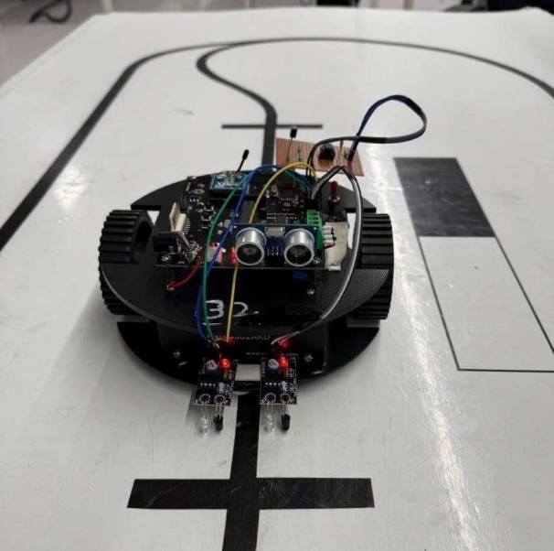
Figure 12.1: Robocar with Sensors attached

Signature of Faculty member

